PARMIGIANO REGGIANO DOP
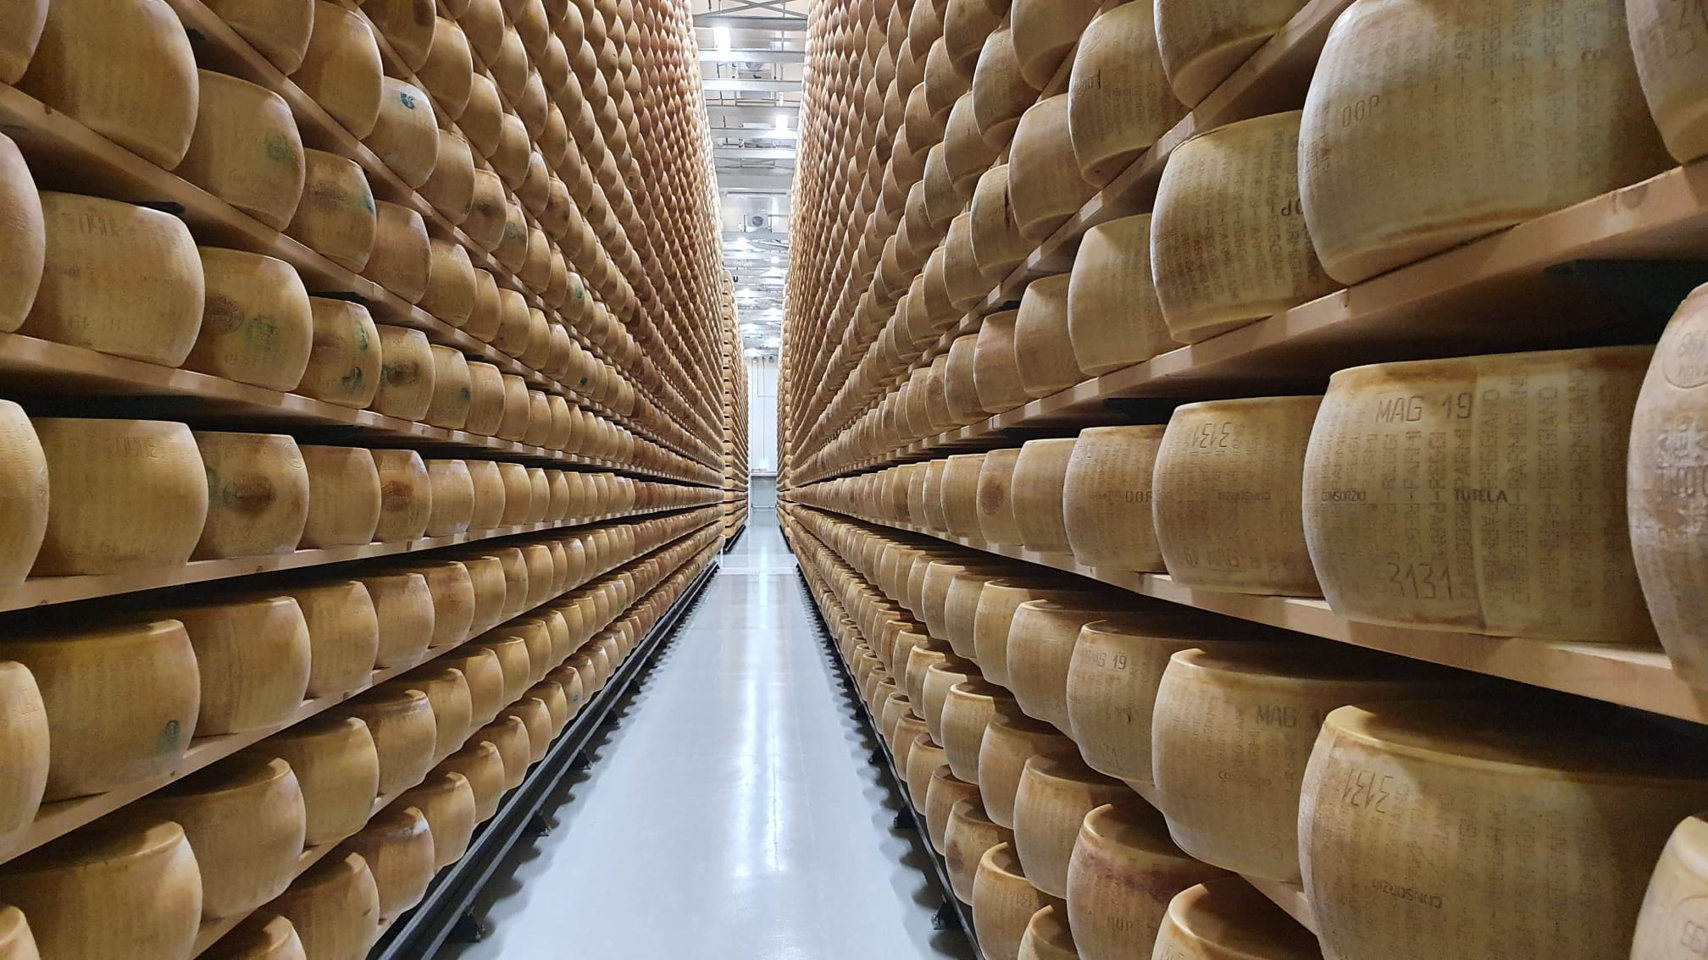

PARMA’S HAM AND NATIONAL HAM
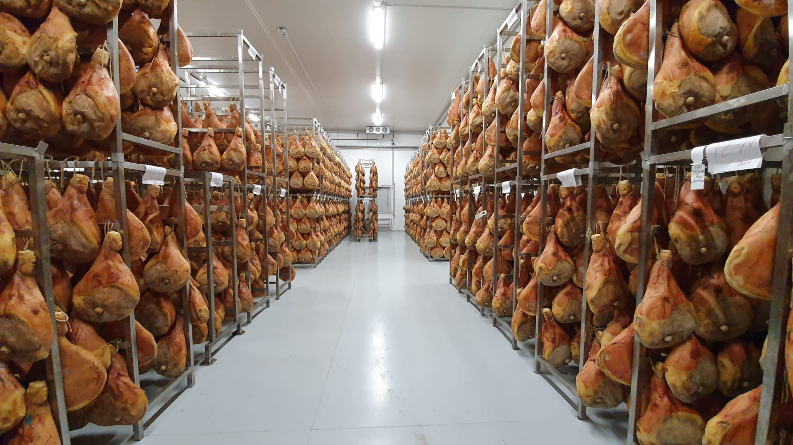

GRANA PADANO
PARMIGIANO REGGIANO DOP

Parmigiano Reggiano Cantarelli Gran Ducato®: a simple and natural product, characterized by a fresh taste that makes it perfect for a quick snack. Seasoning: 12-18 months.
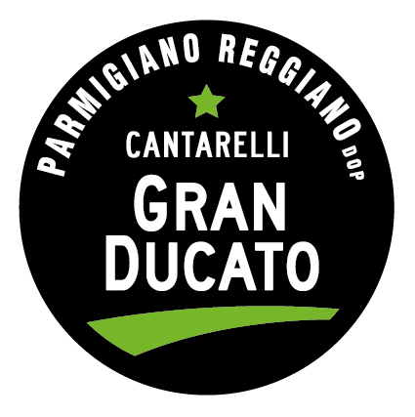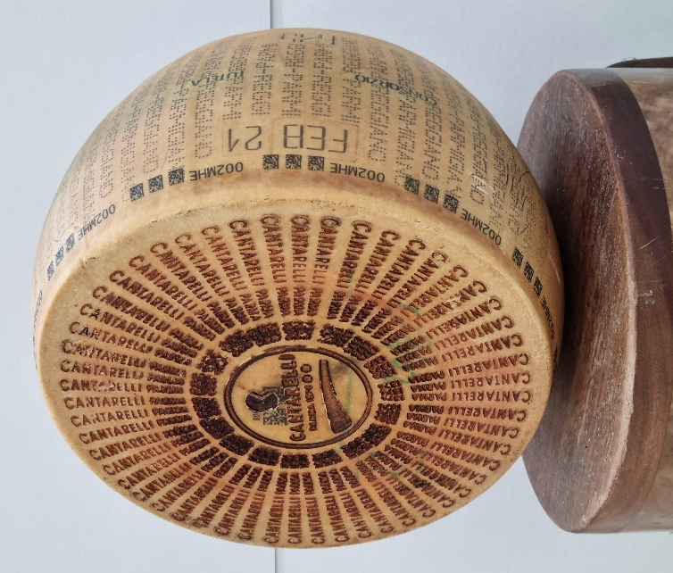

Parmigiano Reggiano Cantarelli Classico®: The ideal selection to dress all the great classics of Italian gastronomy. Even the simplest dish is transformed and amazes. Seasoning: 20-22-24-30-43-52 months.
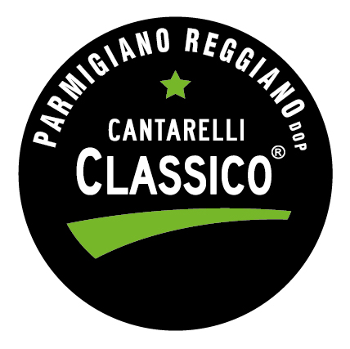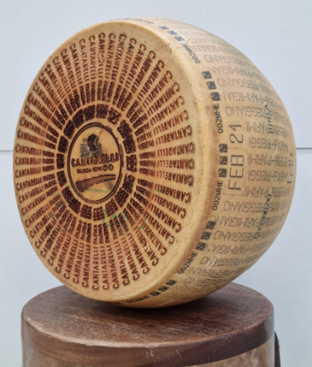
Parmigiano Reggiano Cantarelli Montagna Alta Qualità®: Cantarelli Montagna is the high quality of Parmigiano Reggiano, a registered trademark of the company. It is produced only in dairies located in the Emilian Apennine. Our mountains, thanks to the cool and dry microclimate mitigated by the sea wind, offer the ideal environment for the production of Parmigiano Reggiano, which translates into a superior quality. Mountain Parmesan has a particularly delicate, almost creamy taste that is exalted in long aging. Seasoning: 12-18-24-30-36-40-52- 60 months.
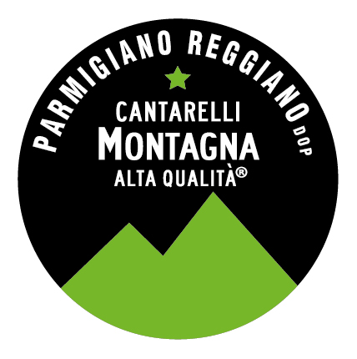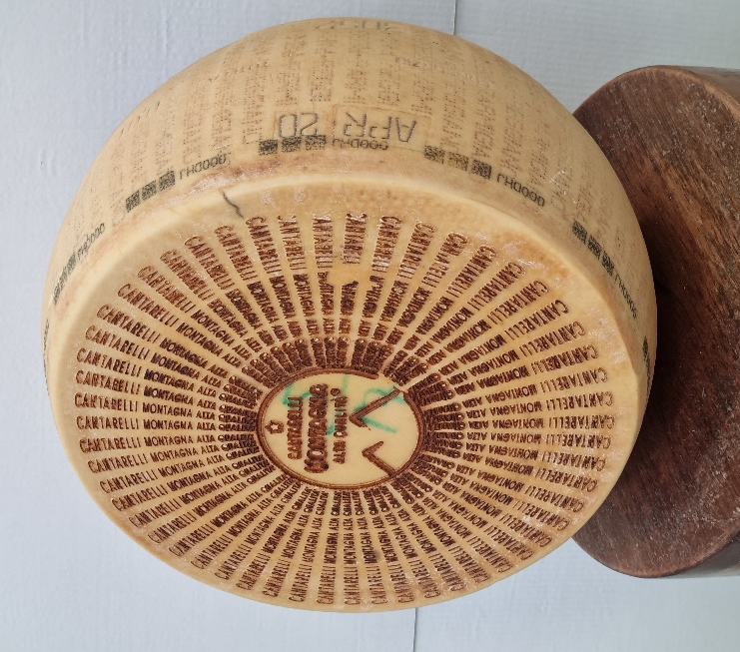
Parmigiano Reggiano Cantarelli Bardi®: the excellence, the elite of the Parmigiano Reggiano. Bardi is taste, class and fashion. Pure pleasure in all its expressions. A cheese of exceptional quality, richer, sweeter and more fragrant. Seasoning: 24-30-36 months.
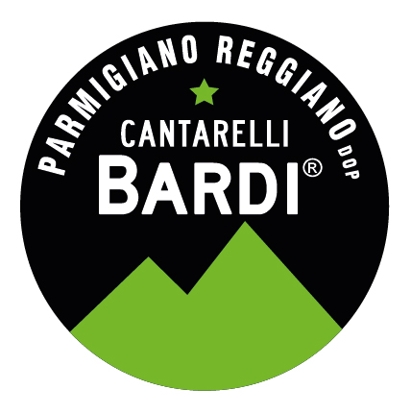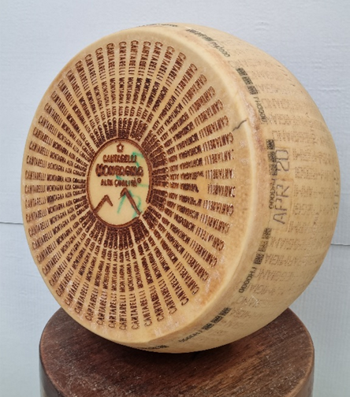
GRANA PADANO DOP

Grana Padano Cantarelli: every single wheel is selected according to qualitative criteria that have distinguished Cantarelli’s working method, obtaining a quality selection also for this Dop. Seasoning: 9-16-20-24 months.

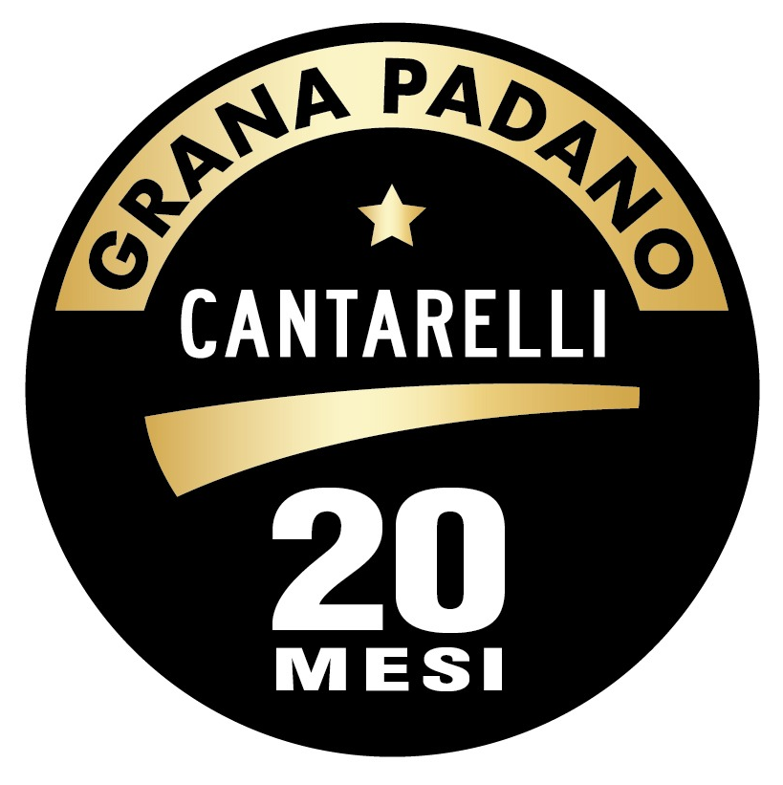

PROSCIUTTO DI PARMA DOP

Prosciutto di Parma Cantarelli: produced in the mountains of the Emilian Appennines they distinghuish themselves for the particular sweetnes and delicacy that are accompained by the intense aroma and taste. They are never dry and melt nicely in the mouth. The focus on consumer health has always been a priority in our projects. This is why we have created hams with a lower salt content and no preservatives. Seasoning: 16-20-24-30 months.

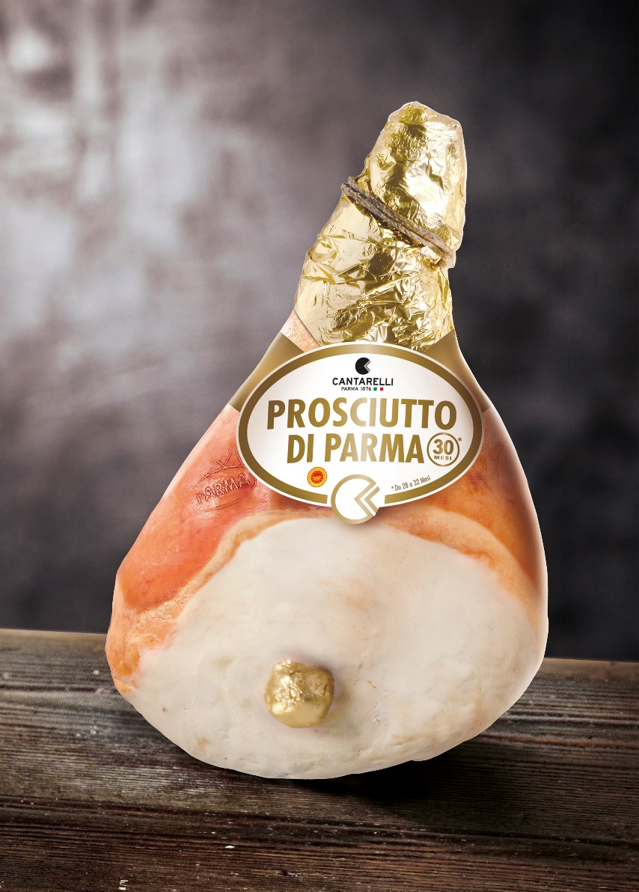

NATIONAL HAM

Crudo Emiliano Cantarelli®: produced with the same meat and in the same processing establishments of Parma’s ham it does not fear the comparison with the famous Parma ham. It is characterized by a surprising sweetness, fragrance and taste of great personality and intensity, a light color and a perfect consistency. Difficult to find another ham whose value for money can compete with our Emiliano ham. Seasoning: 10-14 months.

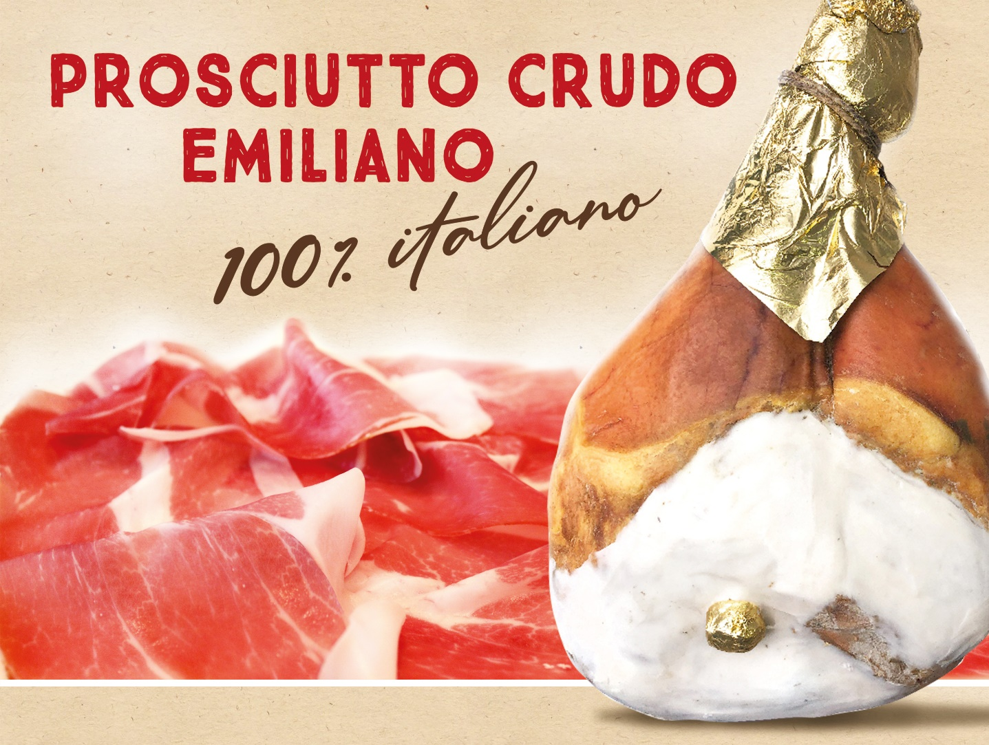

FORMATS AND CUTS

Parmigiano Reggiano and Grana Padano are available in whole wheels and vacuum packed: half wheel, 1/4 (10 Kg.), 1/8 (5 Kg.), 1/8 pre-cut, 2 Kg, 1Kg, 800 gr, 600 gr, 500 gr, 400 gr, 250 gr, 200 gr, 150 gr.

Ham is available with bone, boneless pressed, boneless “addobbo” (trimmered).

