Summary

- Our story
- Iris
- Hemerocallis
- Our selection for United Arab Emirates (UAE)
4.1. Iris
4.2. Hemerocallis
- Price List
- Contact
Our story

Claragarden was founded in the mid-1990s as a field dedicated to the experimentation and hybridization of Iris and Hemerocallis, with the goal of enhancing these fascinating plants through research, selection, and a passion for botanical excellence.

Today, the collection includes over 550 varieties of Hemerocallis and more than 350 varieties of Iris, ranging from historic cultivars to the latest introductions from around the world. It is a one-of-a-kind collection, and among the most prestigious in Europe.

Claragarden is the result of the dedication of Daniele Bilancioni, in collaboration with his brothers Stefano and Federico, partners of Vivai Bilancioni in Bellaria Igea Marina (Rimini), a garden center with over 100 years of history in Italian horticulture. Also specializing in the design of parks and gardens, Vivai Bilancioni has long been a point of reference for those seeking quality, expertise, and aesthetic sensibility, with a portfolio that includes some of the most beautiful villas in Italy.

Today, thanks to the experience gained over time and the professionalism of a highly qualified team, Claragarden is reaching out to the international scene, with the ambition to bring its collection beyond Italy’s borders and offer every garden a touch of uniqueness, elegance, and authentic Made in Italy style.
Be inspired.
Let beauty bloom in your spaces.

Iris
Iris are perennial, hardy, and low-maintenance flowers that adapt well to poor soils and require minimal watering. They are characterized by three upward-facing petals and three downward-facing sepals, along with a style that is also divided into three parts. Iris flowers come in a wide range of colors—fittingly, as the name Iris means “rainbow” in Greek.
There are many varieties of Iris, which can be categorized based on their height (tall bearded, intermediate/border, and dwarf), color patterns (amoena, plicata, bicolor, reverse bicolor, variegata, glaciata, space age, broken color, luminata), and bloom period (early, mid-season, late, and reblooming).
Key Features
- They do not tolerate water stagnation, which can cause the rhizome to rot
- They require full sun exposure and have excellent drought tolerance
- They prefer well-drained, even poor soils, and do not thrive in heavy or waterlogged soils
Planting
The best time to plant Iris is from June to October. Planting should be adapted to the rhizome by amending the soil with sand, slightly raising the planting area a few centimeters above ground level and planting the rhizome shallowly. It is advisable to use organic-mineral fertilizers with an NPK ratio of 6-8-12.

Hemerocallis
Hemerocallis are extremely hardy perennial herbaceous plants that can adapt to a wide range of temperatures, tolerating harsh winters down to -15°C (5°F) and scorching summers up to +60°C (140°F). Thanks to their rhizomes with thick, fleshy, fibrous roots that can absorb large amounts of water, they are capable of withstanding long periods of drought. However, regular watering promotes and enhances both blooming and reblooming.
The leaves are strap-shaped and grow in light green clumps, while the flowers, grouped in racemes, bloom in great numbers during summer. Each individual flower lasts only one day (Hemerocallis in Greek means “beauty of a single day”). Nevertheless, due to the high number of flower buds and the continuous production of reblooming scapes, the plant can flower for up to 60–90 days.
Hemerocallis varieties can be described using specific terminology based on flower shape: round, large blooms up to 18 cm (7 in) with wavy edges in various colors and vibrant eyezones, elongated flowers with narrow petals only a few centimeters wide, and even blooms reaching up to 25 cm (10 in) in diameter. They can also be classified by foliage type: evergreen (persistent), dormant (deciduous), and semi-evergreen (leaves significantly reduce during winter). Additionally, Hemerocallis varieties can be diploid (with a normal double chromosome set) or tetraploid (with a doubled chromosome set), the latter generally being associated with greater hardiness, robustness, flower size, and more complex color combinations.
Key Features
- Do not tolerate waterlogging
- Require at least 5 hours of sun per day to trigger flowering, which is encouraged by regular watering; however, they have excellent drought resistance
- Prefer medium-textured, rich soils, though they also adapt to heavier or sandy soils if amended with organic compost or peat at planting
Planting
Planting can be done throughout the year, except when the ground is frozen or during the peak of flowering.

Our Iris Selection (UAE)
"Iris: a symbol of hope, faith, and life;
that enchanting flower that never truly fades"
The following selection is dedicated to the United Arab Emirates. Our full collection includes many more varieties, which can be viewed online and are subject to availability.

Autumn Circus
Ben Hager 1990

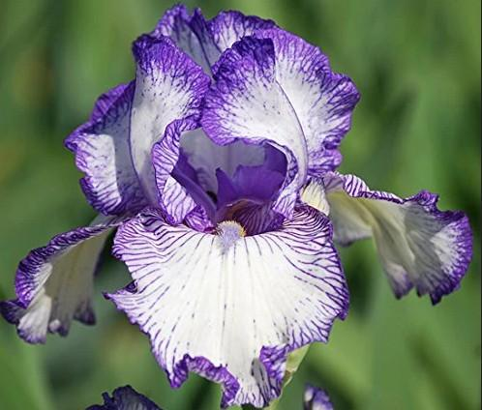
Iris with a white background flower; edges striped with bright purple

Type: Tall bearded, reblooming
Height: 90 cm
Flower size: 15 cm
Fragrance: strong fragrance
Plant density/plants per m²: 5 (spacing 30-40 cm)
Resistance: -20°C/+50 °C
Bloom: May, June, July
Use: perfect for borders, flower beds and group plantings
Dracula Kiss
Schreiner 2009

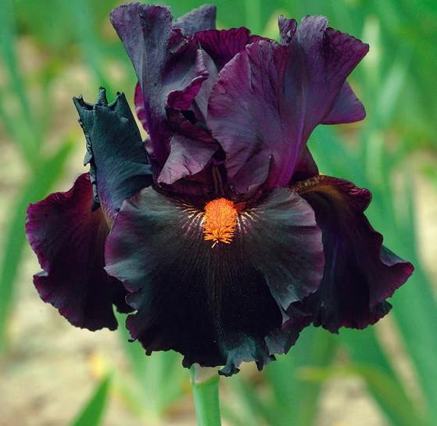
Iris with plum-purple flowers that darken to nearly black-violet in autumn. Its most striking feature is the bright mandarin-colored beards, resembling those of a caterpillar.

Type: Tall bearded, non-reblooming
Height: 90 cm
Flower size: 13-15 cm
Fragrance: not fragrant
Plant density/plants per m²: 4/6
Resistance: -20°C/+50 °C
Bloom: April, May
Use: perfect for borders, flower beds and rock gardens

Darling Deception
Thomas Johnson 2012

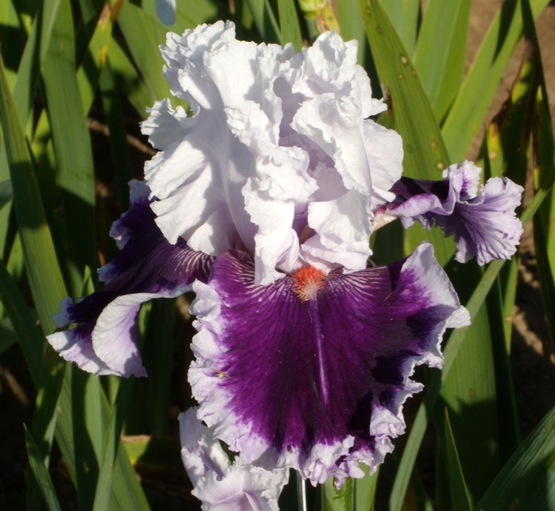
Exuberant and sumptuous! White petals subtly tinted with pale pinkish-violet near the base. Dark purplish-violet falls with broad white edges. Mandarin-colored beards. Large, wide flowers with very pronounced ruffles

Type: Tall bearded, non-reblooming
Height: 89 cm
Flower size: 15-20 cm
Fragrance: delicate, light and subtle fragrance
Plant density/plants per m²: 2-3 (spacing 30-40 cm)
Resistance: -40°C/+50 °C
Bloom: April, May
Use: perfect for mixed borders, flower beds and planters

Excuse Me Darling
Barry Blyth 2001

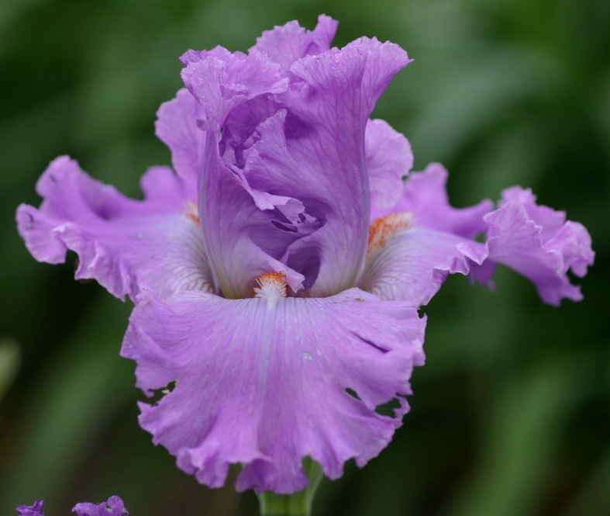
Elegant and luminous; sumptuous form with broad, well-proportioned ruffles. The color is a lilac with brilliant silver highlights and a beard speckled with coral. A plant of remarkable vigor

Type: Tall bearded, non-reblooming
Height: 86 cm
Flower size: 15-20 cm
Fragrance: light fragrance with a musky note
Plant density/plants per m²: 6-9 (spacing 25-30 cm)
Resistance: -40°C/+38 °C
Bloom: April, May
Use: perfect for mixed borders, flower beds and themed gardens

Leading Light
George Shoop 1998

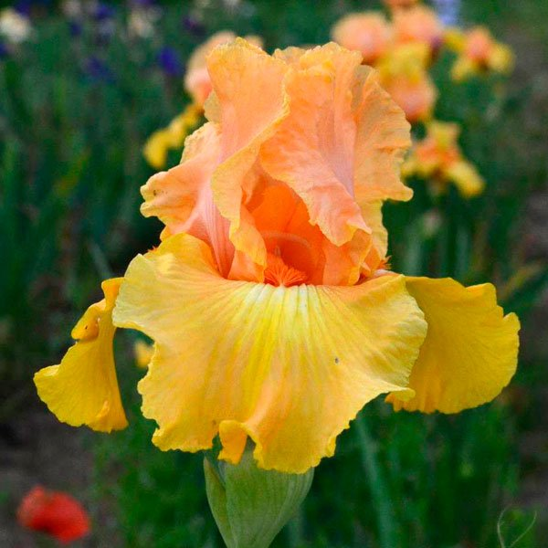
A truly eye-catching and radiant variety. Bright orange tones with an intense carrot-colored beard. Numerous buds on well-proportioned, sturdy stalks

Type: Tall bearded, non-reblooming
Height: 95 cm
Flower size: 6-10 cm
Fragrance: light sweet fragrance
Plant density/plants per m²: 2-4 (spacing 20-30 cm)
Resistance: -20°C/+35 °C
Bloom: April, May, June
Use: perfect for mixed borders, flower beds and planters

Sea Power
Keppel 1999

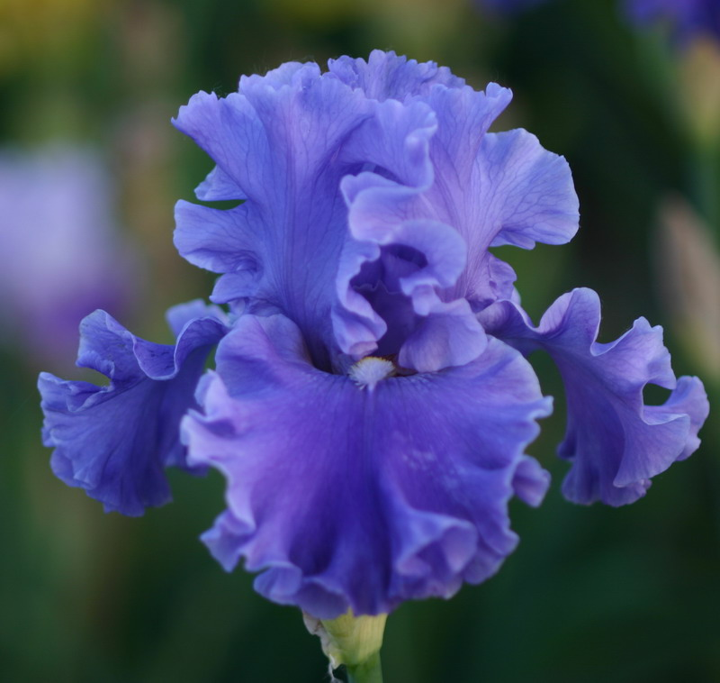
Type: Tall bearded, non-reblooming
Height: 95\97 cm
Flower size: 15\20 cm
Fragrance: delicate and sweet fragrance with floreal notes
Plant density/plants per m²: 3\4 (spacing 30-35 cm)
Resistance: -40°C/+35 °C
Bloom: April, May, early June
Use: perfect for mixed borders, solitary beds, rock gardens and planters

Ruffled like the deep blue sea! Flowers with very frilly petals that open in an intense cornflower blue, becoming slightly paler over time

Solo flight
Larry Johnson 2004

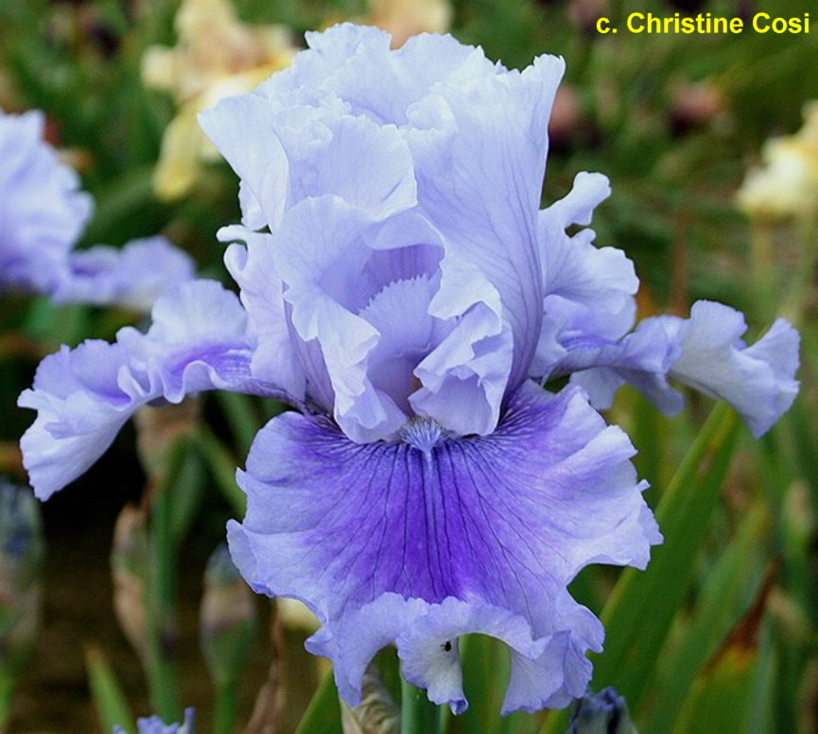
Purity, fine and delicate. This variety features sky-blue stems with streaks of deep lavender that gradually fade. The beards are orange with blue tips

Type: Tall bearded, non-reblooming
Height: 86 cm
Flower size: 15\18 cm
Fragrance: light fragrance
Plant density/plants per m²: 3\5 (spacing 20-40 cm)
Resistance: -34°C/+35 °C
Bloom: May, June
Use: perfect for mixed borders, solitary beds, rock gardens and planters

Stop flirting
Barry Blyth 2004

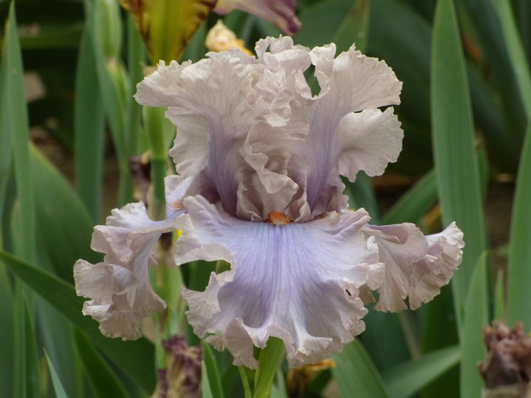
Mysterious grey-lavender with an edge that fades into fawn and a toasted orange beard. The flower shape is statuesque, and the plant has impeccable proportions
Type: Tall bearded, non-reblooming
Height: 97 cm
Flower size: 12\15 cm
Fragrance: light fragrance
Plant density/plants per m²: 6\9 (spacing 20-40 cm)
Resistance: -30°C/+24 °C
Bloom: May, June
Use: perfect for mixed borders, solitary beds, rock gardens and planters

Splatter Matters
John Painter 2009

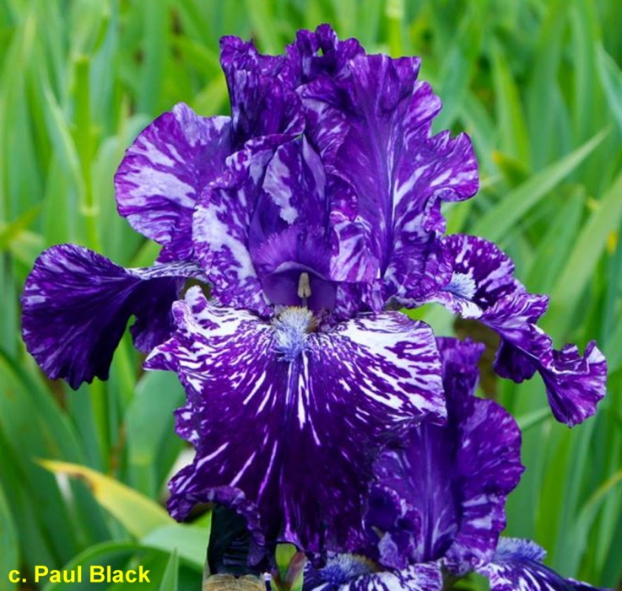
Distinctive and impressive; it features purple and white streaks all over the flower. Mixed purple, white, and yellow beards
Type: Tall bearded, non-reblooming
Height: 89 cm
Flower size: 15\18 cm
Fragrance: light spicy fragrance
Plant density/plants per m²: 7 (spacing 30-50 cm)
Resistance: -34°C/+30 °C
Bloom: April, May
Use: perfect for beds, cutting gardens and planters

That’s All Folks
William Maryott 2005

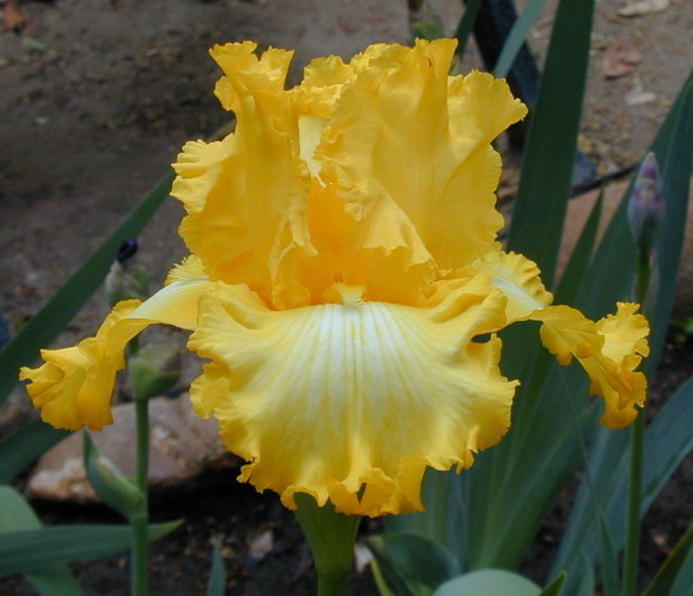
Vigorous and impressive plant, large flower, one of the most beautiful yellow irises on the market. Solar yellow standards, white falls with bright yellow veining that intensifies towards the edge, which is wavy and fringed

Type: Tall bearded, non-reblooming
Height: 102 cm
Flower size: 15\20 cm
Fragrance: not fragrant
Plant density/plants per m²: 2\4 (spacing 50-60 cm)
Resistance: -37°C/+24 °C
Bloom: May, June
Use: perfect for beds, borders, rock gardens, and planters

When Doves Cry
Thomas Johnson 2018

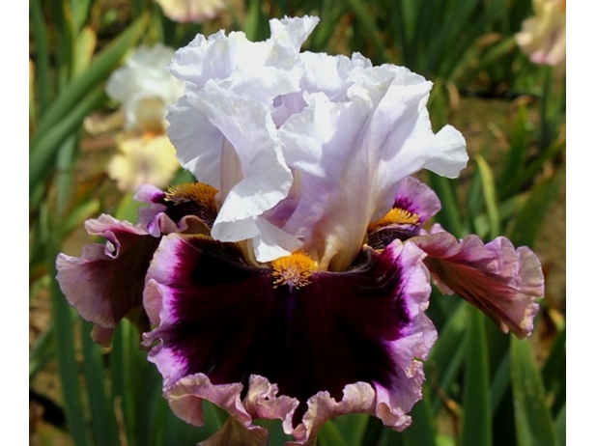
Clean and refined. The standards are ice white with slight lemon highlights, especially in the central part. The flowers are a deep burgundy with wide and precise lavender bands and a darker edge. The beautiful orange beards contrast pleasantly with the burgundy falls. It is one of the favorites and widely used in hybridization

Type: Tall bearded, non-reblooming
Height: 91 cm
Flower size: 15\20cm
Fragrance: light and delicate fragrance
Plant density/plants per m²: 5 (spacing 30 cm)
Resistance: -28°C/+40 °C
Bloom: May, June
Use: perfect for beds, borders, rock gardens, and planters

Wintry Ski
Keith Keppel 2002

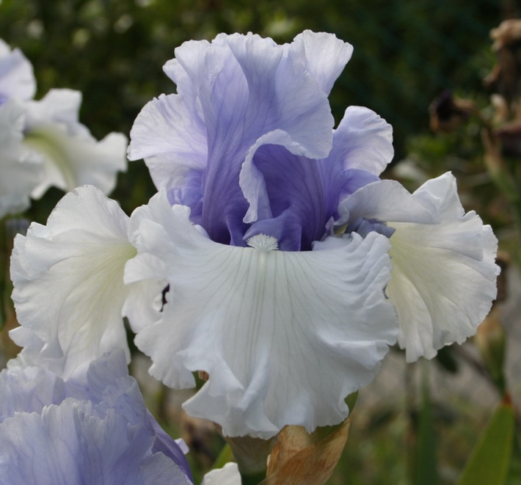
Elegance, vigor, class. Sumptuous flower with broad ruffles and perfect proportions. White falls, gentian blue standards

Type: Tall bearded, non-reblooming
Height: 91 cm
Flower size: 13\15 cm
Fragrance: very light, almost absent.
Plant density/plants per m²: 6 (spacing 30-40 cm)
Resistance: -40°C/+35 °C
Bloom: April, May
Use: perfect for beds, borders, arrangements, and planters

Our Selection of Hemerocallis (EAU)

“Hemerocallis: a daily bloom that enchants with vibrant colors and elegant forms. A flower that continues to surprise, never losing its charm”

The following selection is dedicated to the United Arab Emirates. Our full collection includes many more varieties, which can be viewed online and are subject to availability.
Tropical Heat Wave
Kirchhoff 1992

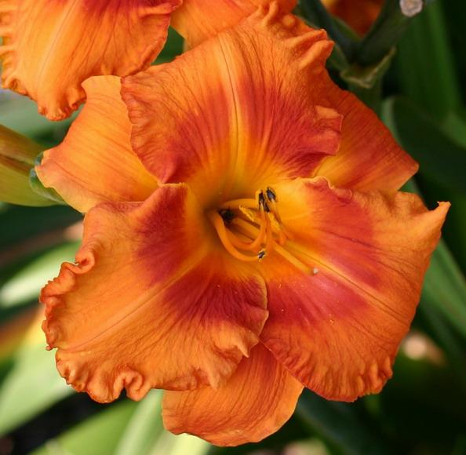
Hemerocallis in a brilliant fiery orange, enhanced by a red eye and edge. Its shape is broad and full, with petals that overlap elegantly

Type: Tetraploid, evergreen, reblooming
Height: 71 cm
Flower size: 15-18 cm
Fragrance: none
Plant density/plants per m²: 4-6 (spacing 40-45 cm)
Resistance: -10°C/+30 °C
Bloom: summer (between June and August)
Use: Ideal for ornamental gardens, perfect for borders, beds, and rock gardens. Also suitable for containers on terraces or balconies. Hardy and ideal for low-maintenance gardens.

Snow Crystal
Stamile 2008

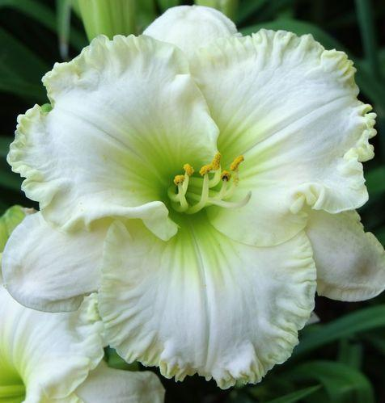
Hemerocallis in ivory white with a golden edge and a green throat, creating a beautiful contrast
Type: Tetraploid, evergreen, reblooming
Height: 76 cm
Flower size: 14 cm
Fragrance: Light, noticeable during daytime hours

Plant density/plants per m²: 4\6 (spacing 40-45 cm)
Resistance: -15°C/+30 °C
Bloom: Early, daytime
Use: perfect for borders, beds, rock gardens, and containers. Ideal for elegant gardens.

Omomuki
Stamile 1991

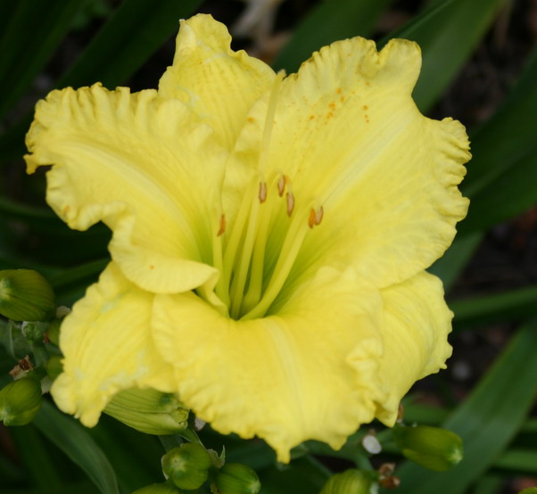
Hemerocallis in chartreuse yellow (intense yellow-green) with a green throat. A unique variety with a distinctive, fresh, and vibrant color that stands out in the garden

Type: Tetraploid, deciduous
Height: 66 cm
Flower size: 13 cm
Fragrance: light and delicate, noticeable during the daytime
Plant density/plants per m²: 4\6 (spacing 40-45 cm)
Resistance: -15°C/+30 °C
Bloom: intermediate, daytime and extended
Use: perfect for borders, flower beds, rock gardens, and also pots.

Mary’s Gold
McDonell 1984

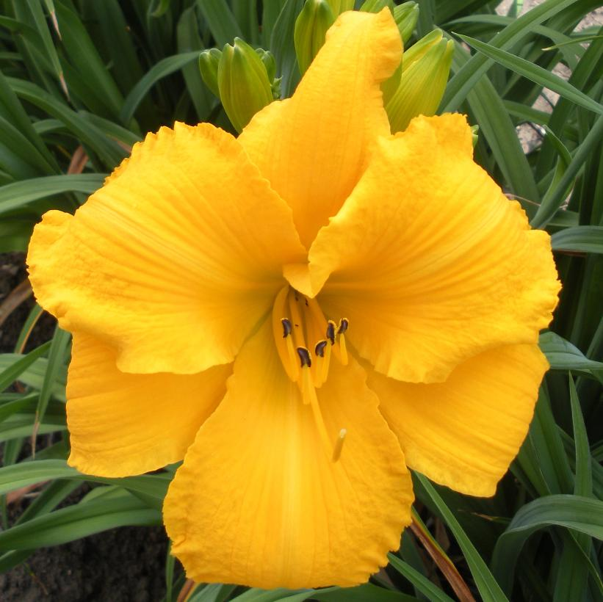
Hemerocallis with bright golden-yellow color and light green throat. The petals are wavy and well-structured, giving the plant an elegant and sunny appearance.

Type: Tetraploid, deciduous
Height: 86 cm
Flower size: 17 cm
Fragrance: delicate and sweet
Plant density/plants per m²: 4\6 (spacing 40-45 cm)
Resistance: -10°C/+35 °C
Bloom: mid-season, daytime
Use: perfect for borders, flower beds, rock gardens, and also pots on terraces and balconies.

Madly Red
Kirchhoff 2002

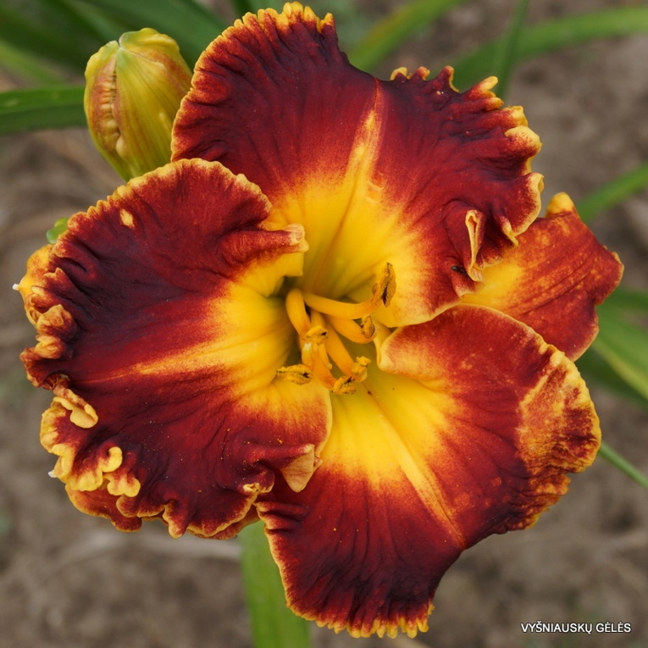
Hemerocallis with intense red color, golden edge, and a throat that fades from yellow to green. It creates a breathtaking visual effect.
Type: Tetraploid, evergreen, re-blooming
Height: 46 cm
Flower size: 13 cm
Fragrance: Not known for a strong fragrance; any scents are light and barely perceptible.
Plant density/plants per m²: 4\6 (spacing 40-45 cm)
Resistance: -15°C/+35 °C
Bloom: very early and extended
Use: perfect for borders, flower beds, rock gardens, and also pots on terraces and balconies.

Doyle Pierce
Grace-Smith 2004

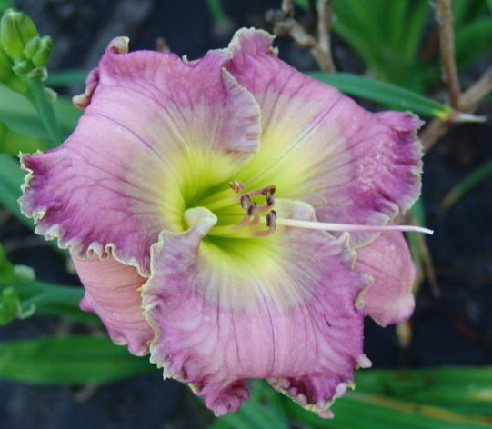
Hemerocallis with lavender tones, enhanced by a central blue "watermark" and a double wavy border of blue and gold, framing the petals. In the center, a bright green throat completes the elegant and sophisticated effect

Type: Tetraploid, semi-evergreen, re-blooming
Height: 86 cm
Flower size: 15 cm
Fragrance: delicate, adding an extra sensory element to the garden.
Plant density/plants per m²: 4\6 (spacing 40-45 cm)
Resistance: -15°C/+35 °C
Bloom: very early, daytime
Use: perfect for borders, flower beds, rock gardens, and also pots on terraces and balconies.

Condilla
Grooms 1977

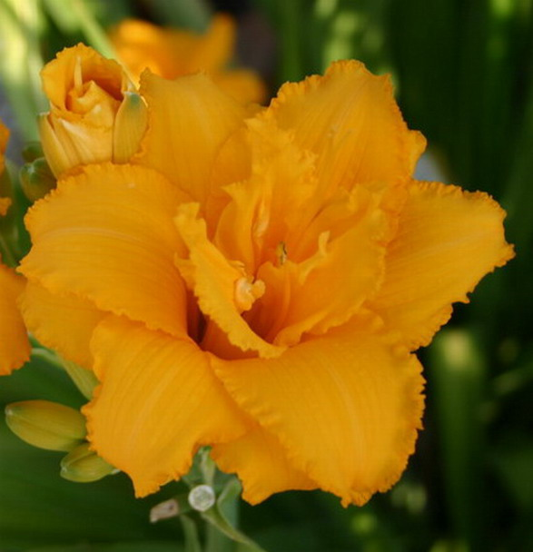
Hemerocallis with an intense and uniform golden color. Its bell-shaped petals open widely, creating a spectacular effect that captures attention in any garden

Type: Diploid, deciduous
Height: 51 cm
Flower size: 11 cm
Fragrance: none
Plant density/plants per m²: 6\8 (spacing 30-40 cm)
Resistance: -15°C/+35 °C
Bloom: very early, daytime
Use: perfect for borders, flower beds, rock gardens, and also pots on terraces and balconies.

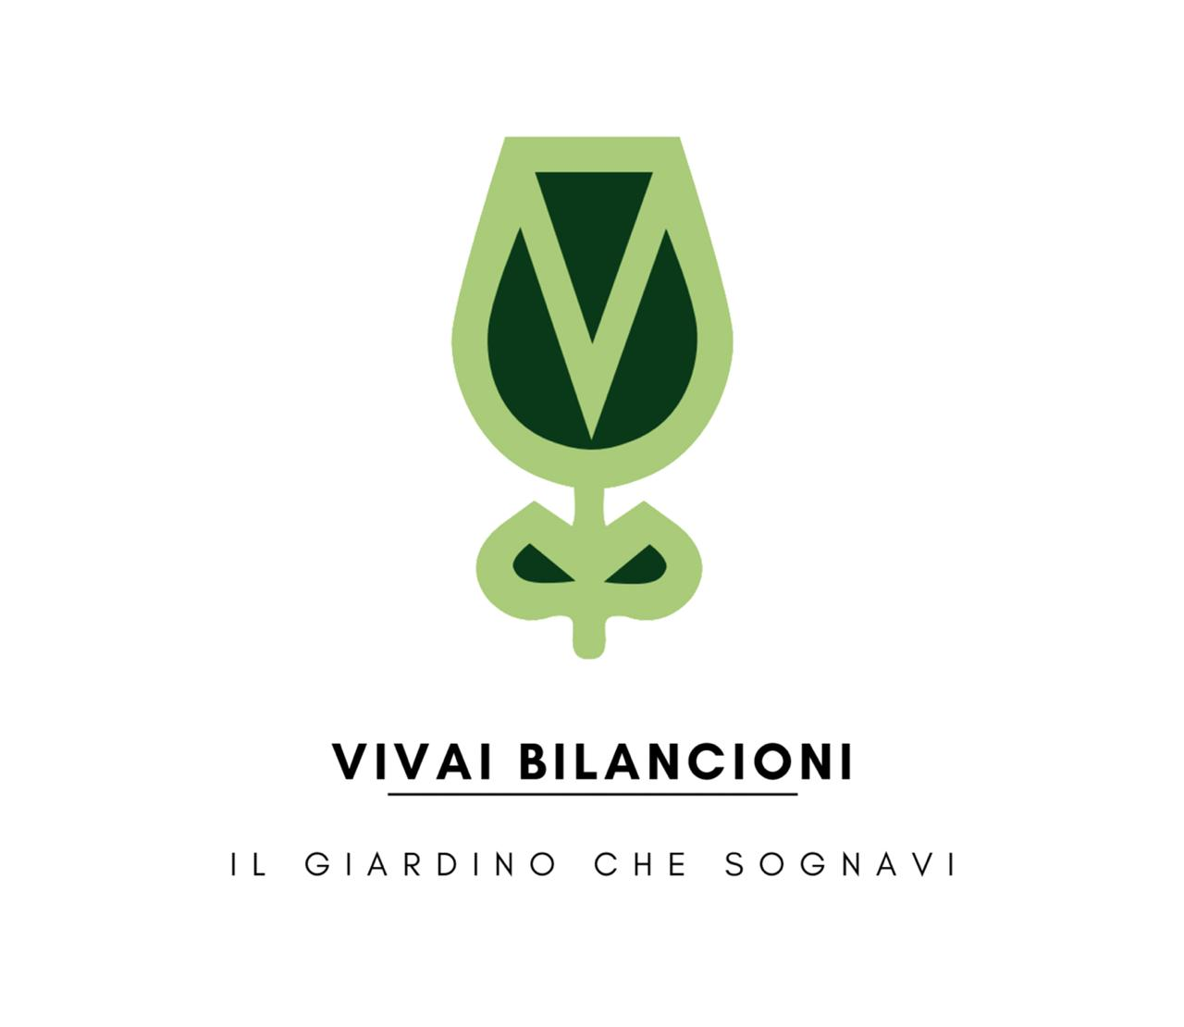

VIVAI BILANCIONI
Via Fermignano 3/7, 47814 Bellaria-Igea Marina (RN), Italy
Email: bilancionipiante@libero.it
Phone: +39 0541 330583
www.vivaibilancioni.it

