FINE TASTE SHOWROOM PRODUCTS DELIVERED

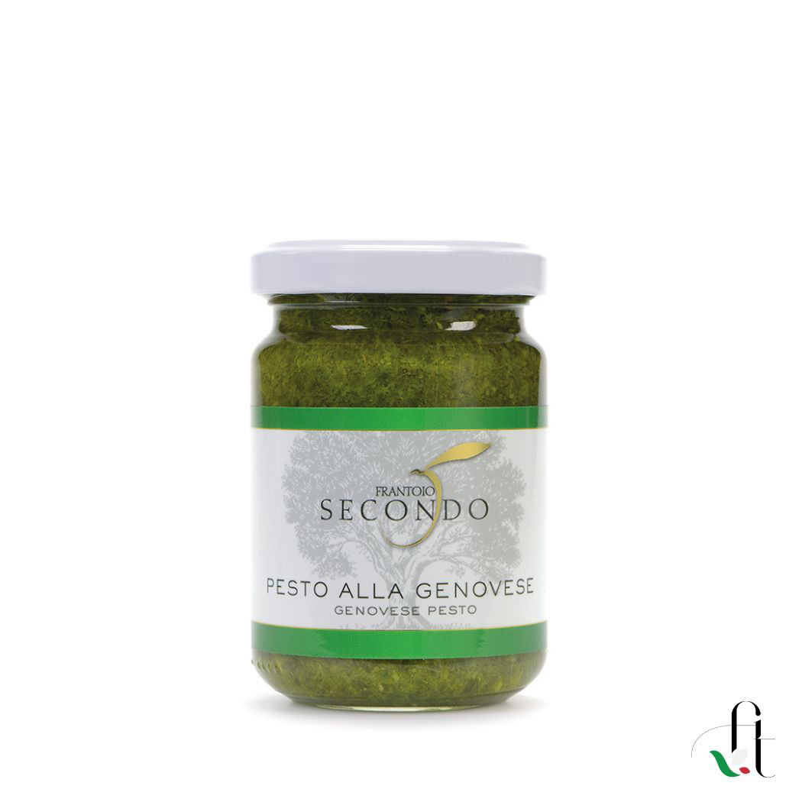

Frantoio Secondo - Genoese pesto with garlic (2 items per 135 gr.)
Pesto alla Genovese is made following the traditional Ligurian recipe based on basil, extra virgin olive oil, pine nuts, Parmigiano Reggiano DOP and garlic. Optimal to season any type of pasta. - Format: 135 gr.
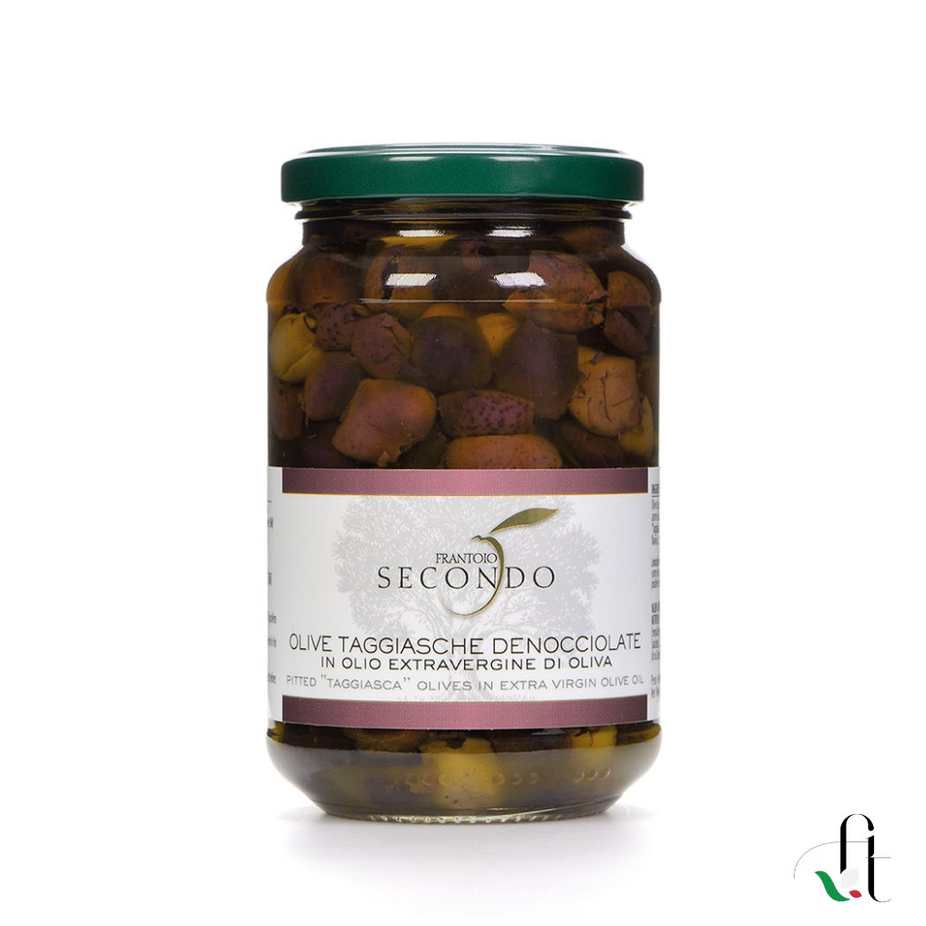
Frantoio Secondo - Pitted Taggiasca olives (2 items per 300 gr.)
Pitted Taggiasca olives in extra virgin olive oil. Excellent to use in salads and sauces or to accompany aperitifs. - Format: 300 gr / 500 gr
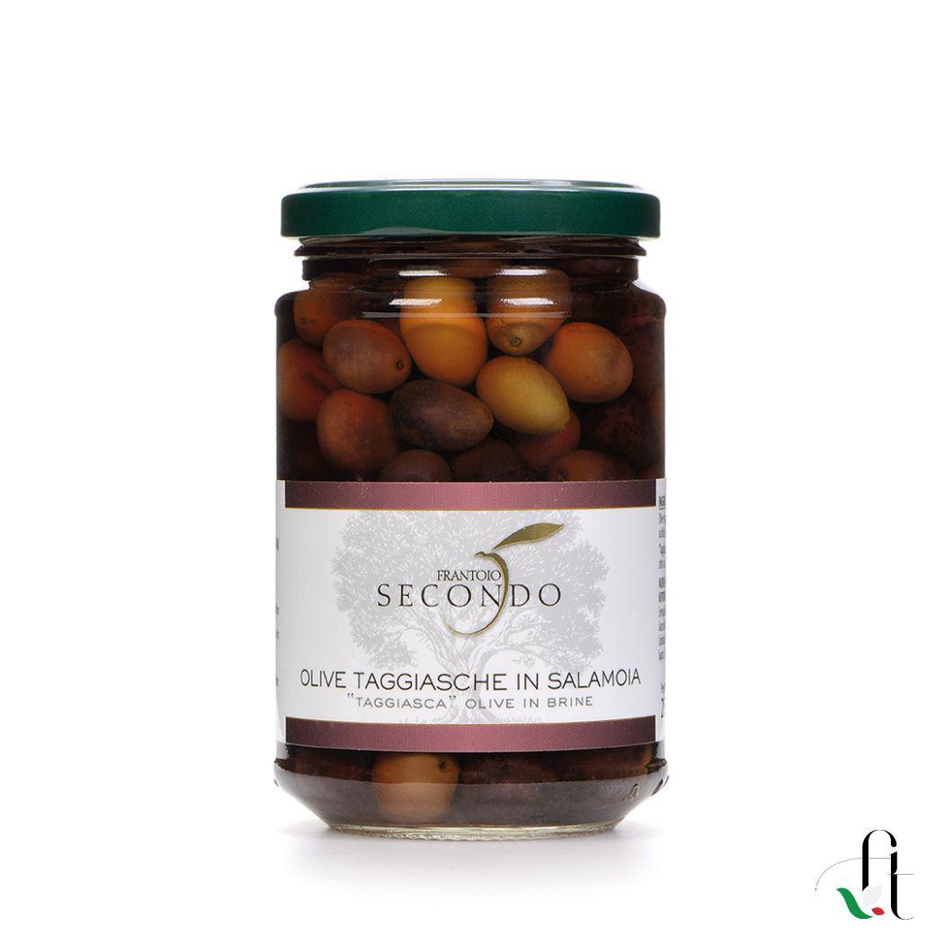
Frantoio Secondo - Taggiasca olives in brine (2 items per 280 gr.)
Taggiasca quality olives carefully selected and subsequently left to rest in water and salt for a few months. Excellent in the kitchen to flavor dishes and to accompany aperitifs - Formats: 280 gr/ 530 gr / 900 gr

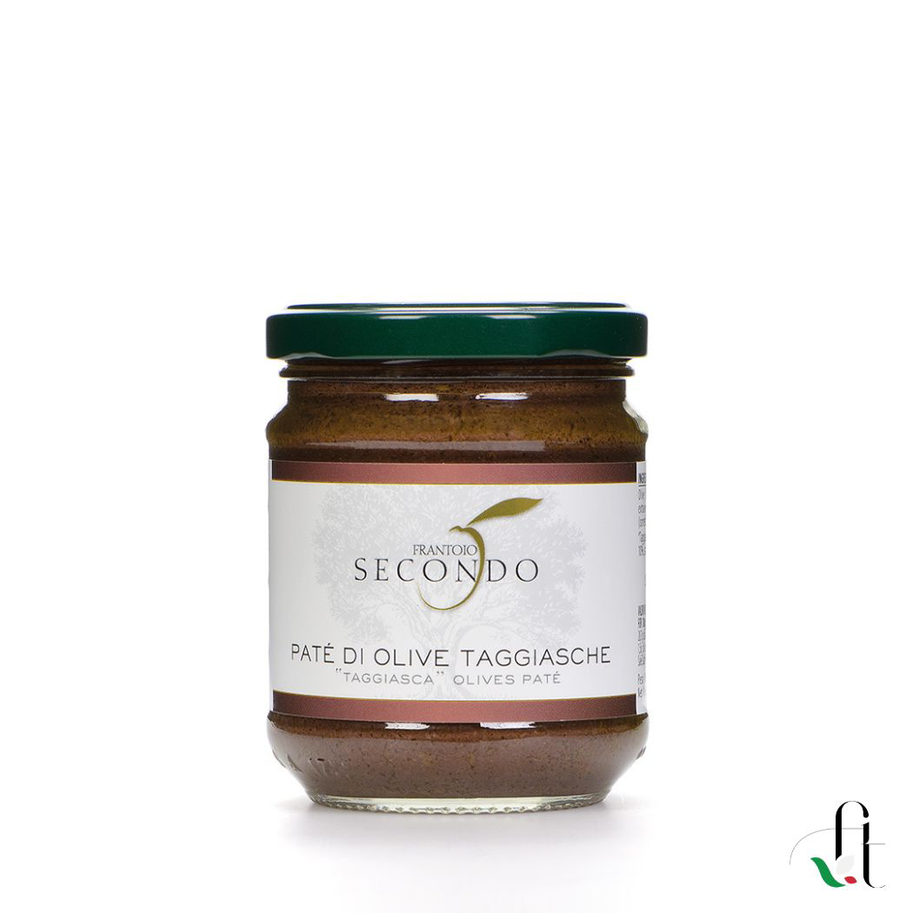
Frantoio Secondo - Taggiasca Olive Patè (2 items per 180 gr.)
Olive Patè is a sauce made from finely chopped pickled Taggiasca olives and olive oil. Excellent for seasoning canapés and bruschetta; ideal on pasta. Format: 180 gr.

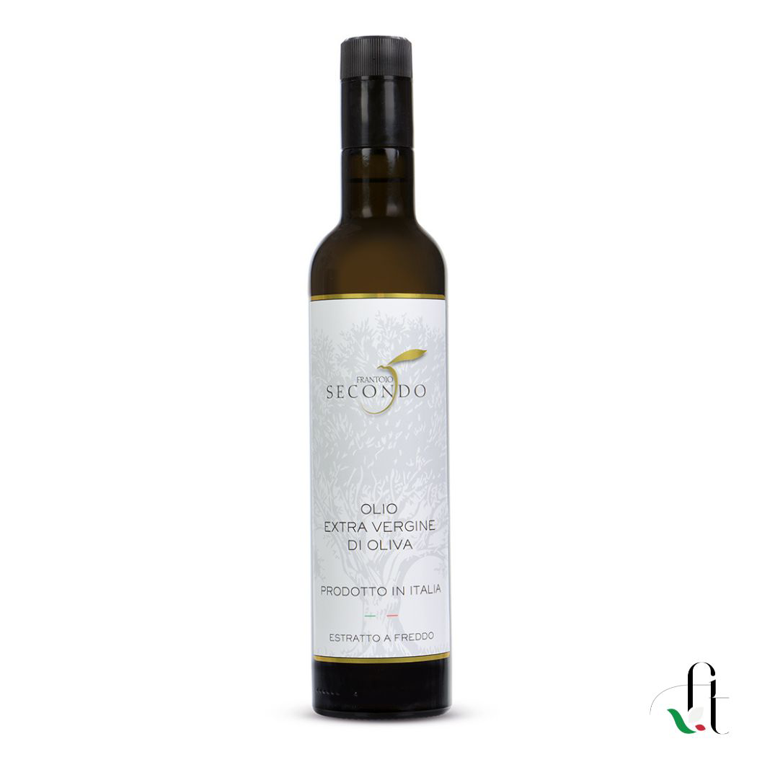

Frantoio Secondo - 100% Italian extra virgin olive oil (2 items per 500 ml.)
Cold-pressed extra virgin olive oil obtained from the processing of olives solely using advanced technology machinery which allows the content to be extracted from the fruit without altering its properties and capable of enhancing the quality, sensorial and organoleptic characteristics of the extra virgin olive oil.
CHARACTERISTICS
Unfiltered oil, any traces of sediment on the bottom are a guarantee of authenticity. With a beautiful color tending towards yellow, with a sweet and light scent and a fruity flavour.
COMBINATIONS Highly versatile oil. Perfect on any type of dish.
OTHER INFORMATION Region: Liguria
Formats: 0.25 lt, 0.50 lt and 0.75 lt bottles

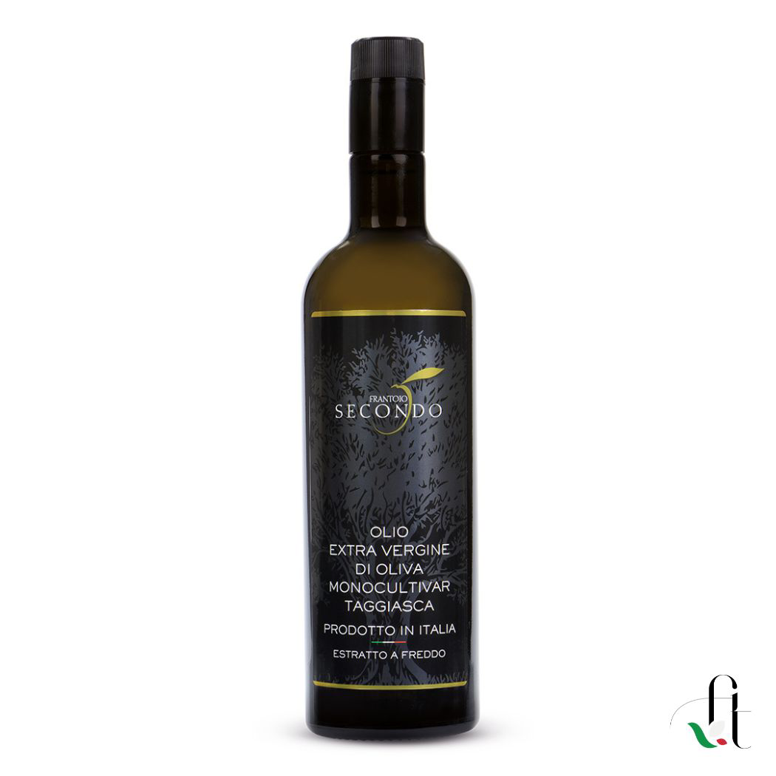
Frantoio Secondo - Taggiasca monocultivar extra virgin olive oil (2 items per 500 ml.)
Taggiasca monocultivar extra virgin olive oil is obtained from the processing of Taggiasca type olives using mechanical procedures of the highest technological level which maintain the sensorial characteristics and organoleptic properties of the extra virgin olive oil intact.
Its quality level is also demonstrated by the coveted awards received over the years.
In 2018 and 2019 he received the “Due Foglie” award from the Gambero Rosso guide to Italian oils.
CHARACTERISTICS
Intense yellow color, faint hint of sweet almond. Full, intense taste but with nuances of delicate sweetness
COMBINATIONS
In the kitchen it accompanies delicate dishes very well thanks to the flexibility of the Taggiasca variety. Ideal for preparing sauces, perfect for preparing pesto at home, for seasoning soups, baked fish, cream soups. Or raw on bruschetta, fish and meat carpaccio, steamed vegetables, salads, dips, pasta, ravioli. To best appreciate its characteristics, pure on a slice of hot bread.
OTHER INFORMATION Region: Liguria Formats: 0.25 lt, 0.50 lt and 0.75 lt bottle

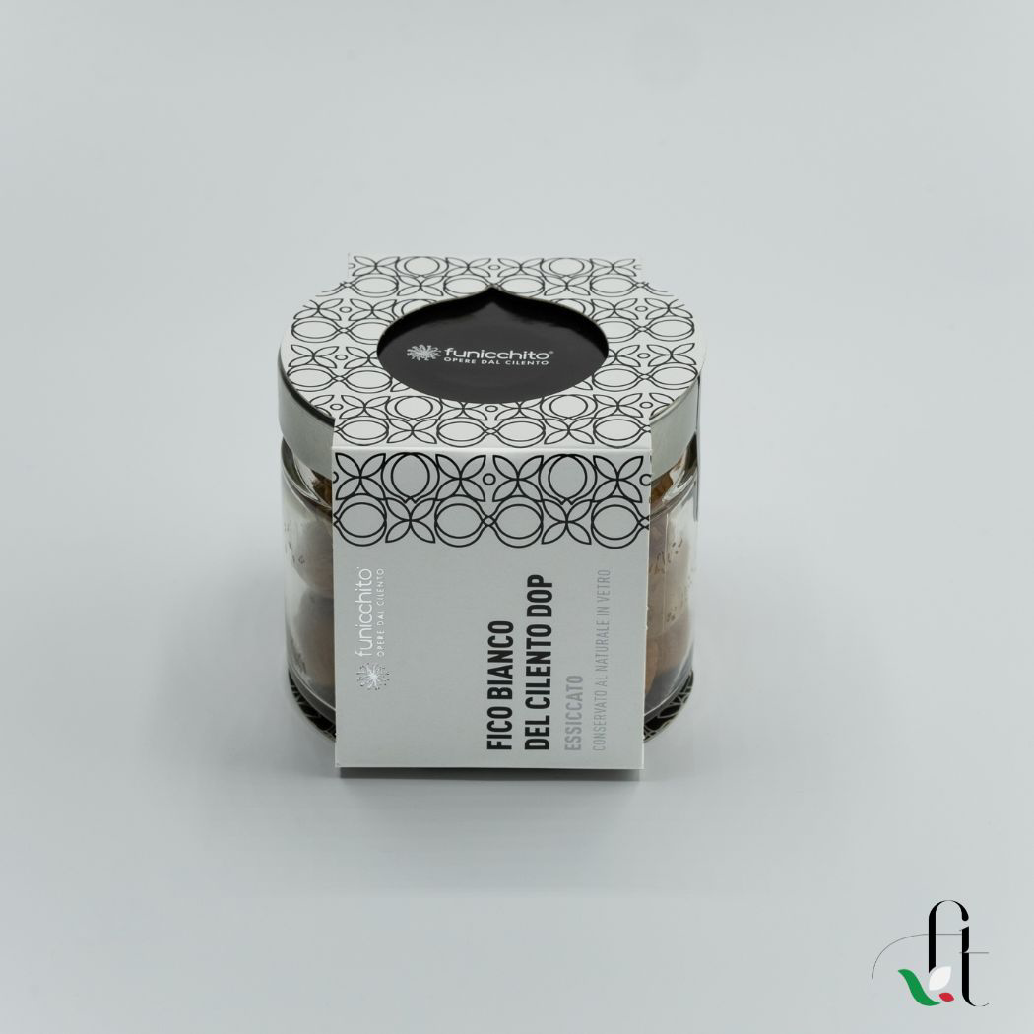

Funicchito - Cilento PDO White Figs dried (6 items per 200 gr.)
Dried WHITE FIGS FROM CILENTO PDO, preserved in natural glass
The figs used are grown in land certified for the cultivation of Fico Bianco del Cilento, they are handcrafted and preserved without the use of chemical treatments.
The fig is an ancient, delicious and simple product. Traditionally a must on holiday tables, it can be enjoyed at the end of a meal or to accompany important cheeses. Let's not forget that the fig also has notable properties: anti-inflammatory, energizing, they reduce the risk of chronic diseases (being rich in Omega 3 and 6) and are useful for regulating blood pressure (thanks to the high potassium component).
Ingredients: FICO BIANCO DEL CILENTO DOP
Product type: Dried figs
Weight 200 gr.

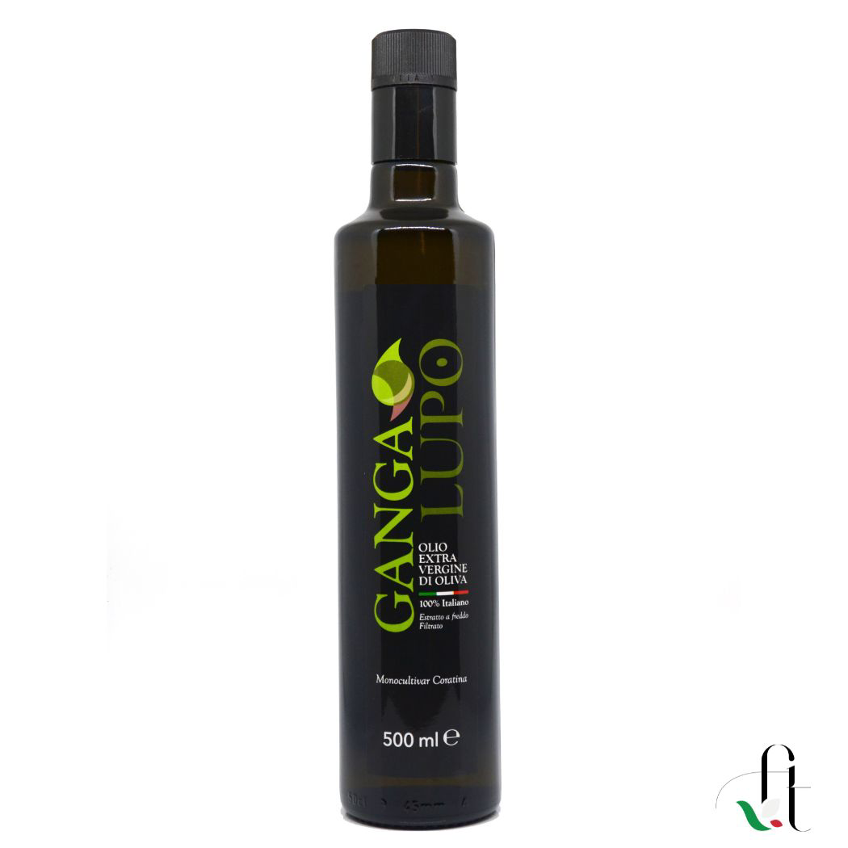

Ganga Lupo - Extra Virgin Olive Oil (4 items per 500 ml.)

This very refined oil has all the characteristics to give you real emotions. Obtained from only pure Coratina olives, harvested by hand, processed almost immediately after harvesting with a 2-phase continuous cycle extraction method, it will only bring all your dishes to levels of excellence and give you a lot of satisfaction.
A limited quantity product, for lovers of outrageously good things!
AWARDS:
Winner of the 2020 International Golden Lion in the “Monovarietals of Italy – Coratina” category
CHARACTERISTICS:
Oil characterized by a medium-intense level of fruity, bitter and spicy, with a prevailing hint of fresh almond and light sensations of herbaceous and artichoke
PAIRINGS:
Oil with a strong character goes well with grilled vegetables, grilled porcini mushrooms, mixed legume soups, tomato salads, grilled meats, mature hard cheeses
OTHER INFORMATION: Puglia region
Packaging: Doric bottle with anti-refill cap for the 500 ml format and Bag in box for 3 and 5 litres, ceramic jar for the gift version.

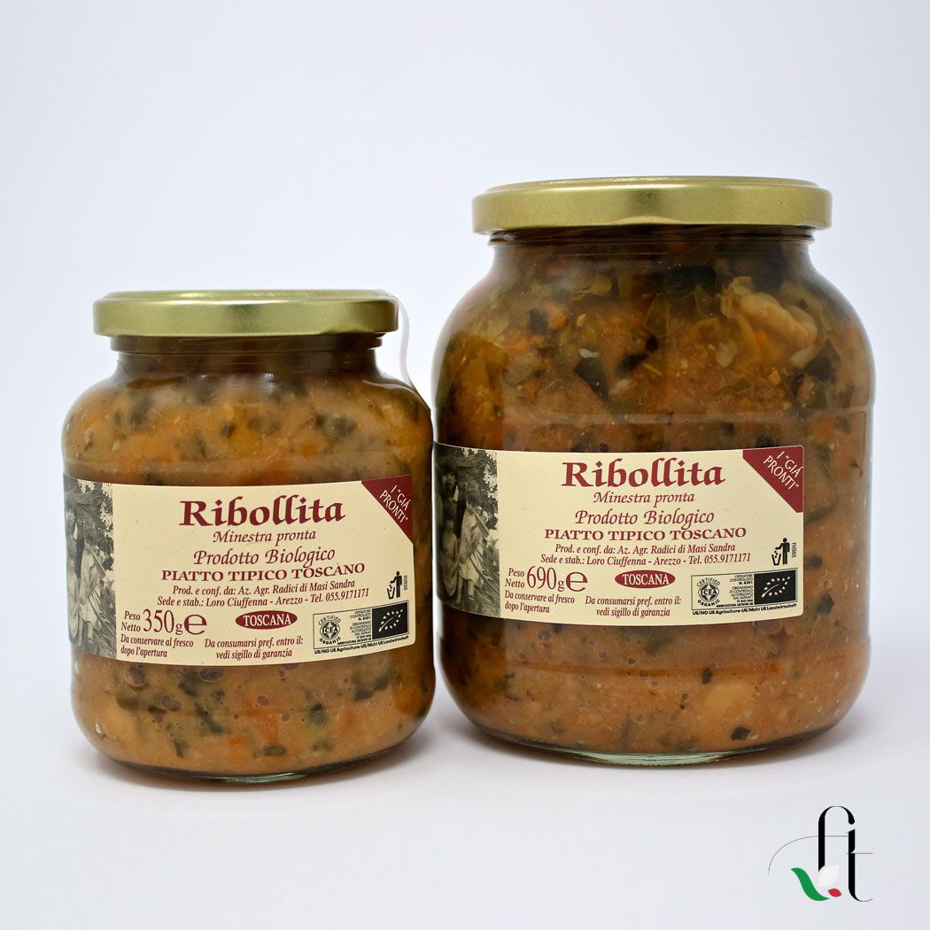

Radici – Artisanal and organic Ribollita (3 items per 350 gr.)
Artisanal and organic ribollita. Radici has a laboratory in Tuscany capable of preparing completely organic soups, transforming the harvest of the fields into healthy and genuine products, without using thickeners, preservatives or colorings. Each product receives special attention and is created with exclusive recipes, with the flavors of the Tuscan tradition.
Ingredients:
Black and savoy cabbage, beans, potatoes, tomatoes, chard, carrots, onions, celery, extra virgin olive oil, salt, aromatic herbs, spices Organic product, without the use of dyes, thickeners, preservatives. Gluten free. Vegan.
Formats: 350 gr./ 690 gr.

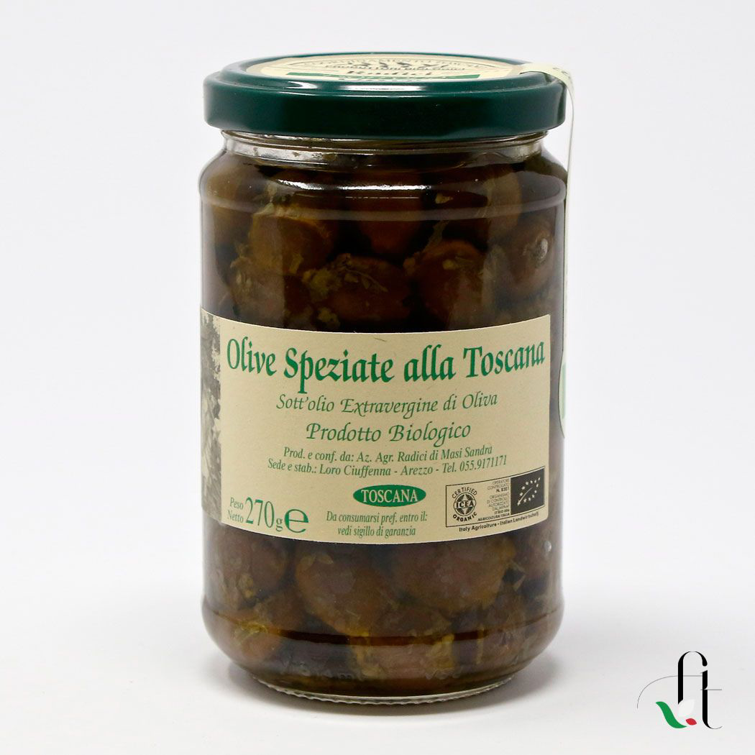

Radici – Artisanal and organic Tuscan-style spiced olives in EVO oil (3 items per 270gr.)

Organic Tuscan Spiced Olives. Radici has a laboratory in Tuscany capable of transforming the harvest into healthy and natural products, without using thickeners, preservatives or colorings. Excellent quality extra virgin olive oil plays a fundamental role with its unmistakable aroma. When tasting it is impossible not to notice the absolute freshness!
Ingredients:
Pitted black olives, extra virgin olive oil, parsley, garlic, oregano Organic product, without the use of dyes, thickeners, preservatives. Gluten free. Vegan.
Excellent on any occasion, aperitif, starter or side dish.
Format: 270 gr.

